2026 Tanglewood Club Championship Recap

The 2026 Club Champion is Brett Barry. Brett followed a nice 69 on the Reynolds with a 68 on the Championship Course today. Eli Kennedy won 2nd Gross at 144. Brady Rockey was 1st Net with a score of 132.
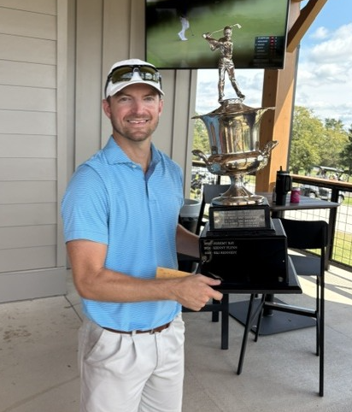

In the Men’s B flight, You Yung won 1st Gross with a 167 with Chad Carter finished 4 strokes back to win 2nd Gross a 171. Michael Gilmore won 1st net with 145. His stepson, Paul Week’s Jr., won 2nd Net with 150.

The 2026 Senior Men’s Club Champion is John Kennedy. John finished at 143. Terry Payne was 2nd at 144. John and Terry were tied after Saturday’s round. Sunday, John pulled 5 strokes ahead of Terry at the turn with a nice 32 on the front. Terry got it rolling on the back with a 34, but John’s 38 was just enough to secure the 1 stroke win. Terry won 1st Net. Our 2nd VP BJ Richardson won 2nd Gross with 146. BJ had a career round on Sunday with a 69 that started with an Eagle on #1 from the trap. Yes, he drove the trap. He did this after handling 10 cases of beer. Second Net was won by Glenn Hurst with a144.


Senior Men’s B was won by our TGA Treasurer Jim Williams. Jim had 83 both days to finish at 166. Jim was up two strokes after Saturday’s round and kept the steady play going on Sunday to win first gross by comfortable margin. 1st net was won by Glenn Makitka at 148. Kyle Smith won 2nd Net at 149.

Senior Men’s C, 1st Gross was won by Al Dollman at 189 with Bob Oswald finishing at 192 to win 2nd Gross. Tim Medema won 1st Net with Keith Vanderpoel finishing 4 shots back to win 2nd Net.
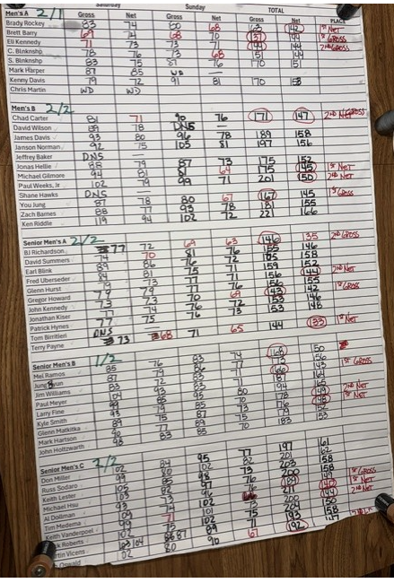

We had really good weather on both days. I have to thank Hugh Quinn for his help on both the Super Senior Club Championship and the Weekend Club Championship. Hugh was everywhere. On the first tee, on the course, and at the scoring table. His help was invaluable. Woody Park spent most of the weekend at the scoring table getting everything recorded and sorted out. Woody and Hugh spent the better part of the weekend helping the TGA, when they didn’t have to, and we appreciate both of your help. BJ did a great job on the refreshments. Jim William’s helps in so many ways, thank you Jim! Our secretary Rob Heflin does a lot of work to make the sign-ups run smoothly and so many other things. Kyle’s daughter Selah got the refreshments out to the course Thanks Rob! I hope the spelling is right. With all the emails, I can’t find the one her name on it.

I’ll send a better Excel version of the scoresheet in a few days but wanted to get the recap out this evening. Scores will be posted tomorrow. I have a favor to ask of everyone. If you have cards in the Proshop, please get them promptly. We are accumulating cards and the Proshop can’t be happy. It takes them longer to get the right card once we get 8 or more cards in the box. We must do our best to maintain the box; we must. We don’t have a locker like we used to have in the old building. We have a cabinet in a restricted area of the new clubhouse. It was a great offer by the Proshop to do this for us. I’ll update the list of cards in the box tomorrow. If we can’t get better at this most difficult task, we pull all the cards except the most current and put them in the cabinet. From the 1st VP view of it, it has become another administrative task that has nothing to do with golf that has to be maintained.

